**Short Manual on How to use the new App to Visualize AP Report Data**

Table of Contents

Table of Contents 1

Introduction 2

About the App 2

Prerequisites 2

1)R (Required) 2

2)R studio (Optional) 2

Visualization 3

What is provided? 3

If you have R studio, 3

If you only have access to R, 5

Understanding the Excel Sheet 6

Updating Excel sheets 6

Understanding the App 7

# Introduction

## About the App

Purpose of creating this app was to help visualize the Integrated Academic Program Report Data. This App enables to compare 2 sets of data. User will be given options to view the result as a Bar graph/line graph. It is possible to only graph the ratio and download the filtered data.

## Prerequisites

### 1)R (Required)

You can download the latest version from [https://cloud.r-project.org](https://cloud.r-project.org/).

### 2)R studio (Optional)

You can download the latest version from <http://www.rstudio.com/download>.

For more detailed information about R you can read the book at <https://r4ds.had.co.nz/>.

# Visualization

## What is provided?

A folder  containing the R Script (The App) and the Unprotected Excel File.

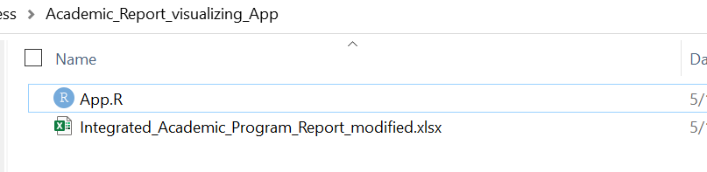

### *If you have R studio,*

* Select the R script (App.R) and will likely open with R Studio.

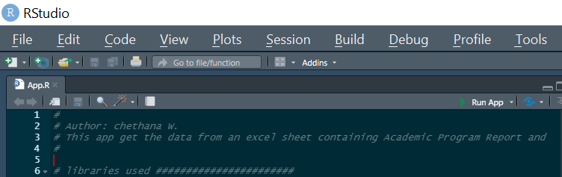

Click the “Run App” Button.

You will be asked to select the file (the excel file does not always need to be next to the App.R)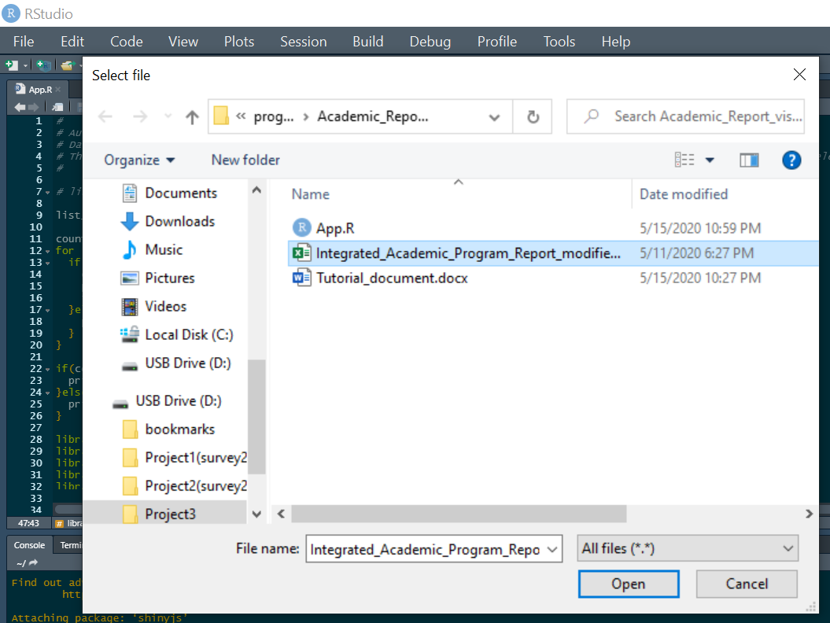

You will see the Window shown below,

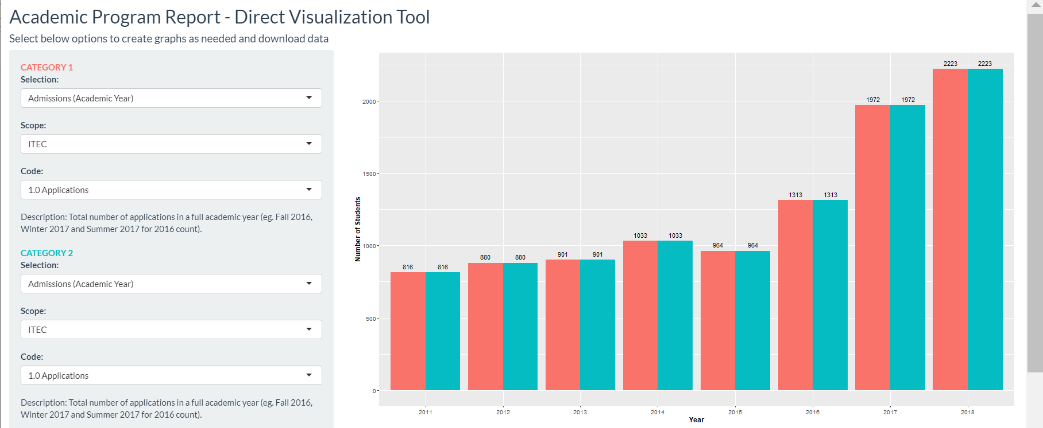

### *If you only have access to R,*

1)Open the R script (App.R) with any simple editor software available (Eg: Notepad, WordPad, Notepad ++ etc) and copy the script (Ctrl+A -> Ctrl+C).

2)Open R in your device

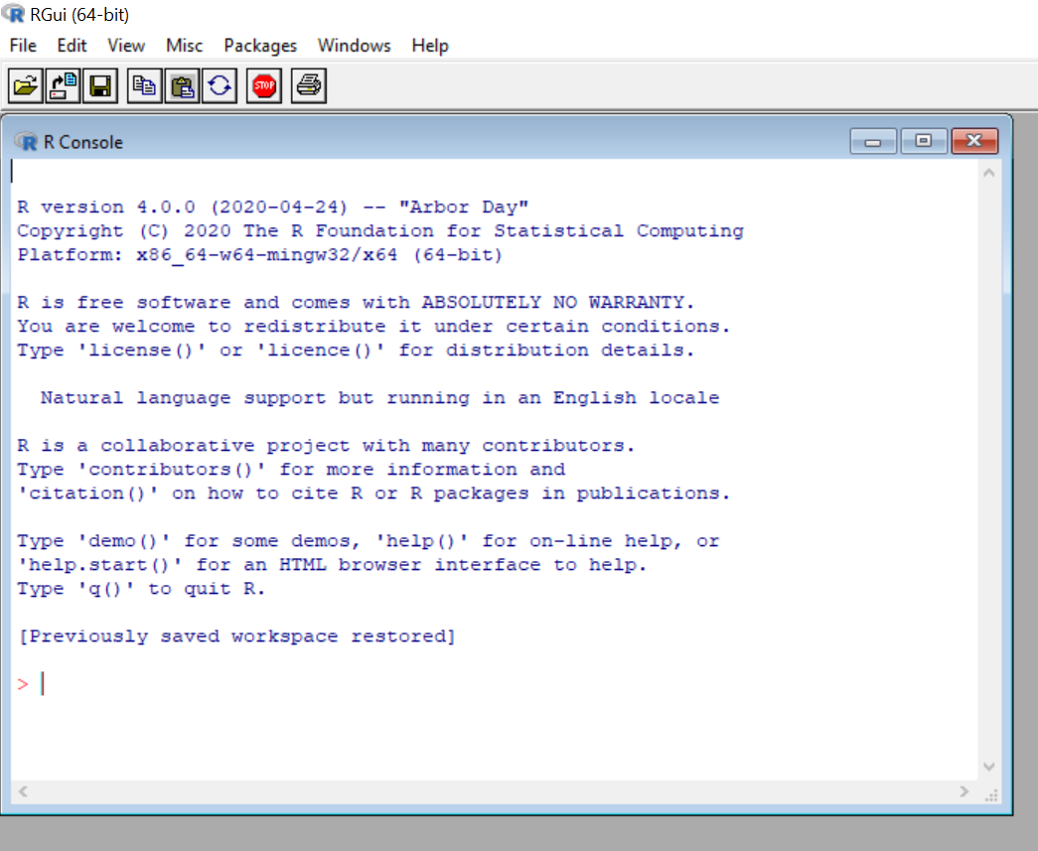

3)Paste the script in R and it will run automatically.

You will be asked to select the file (the excel file does not always need to be next to the App.R)

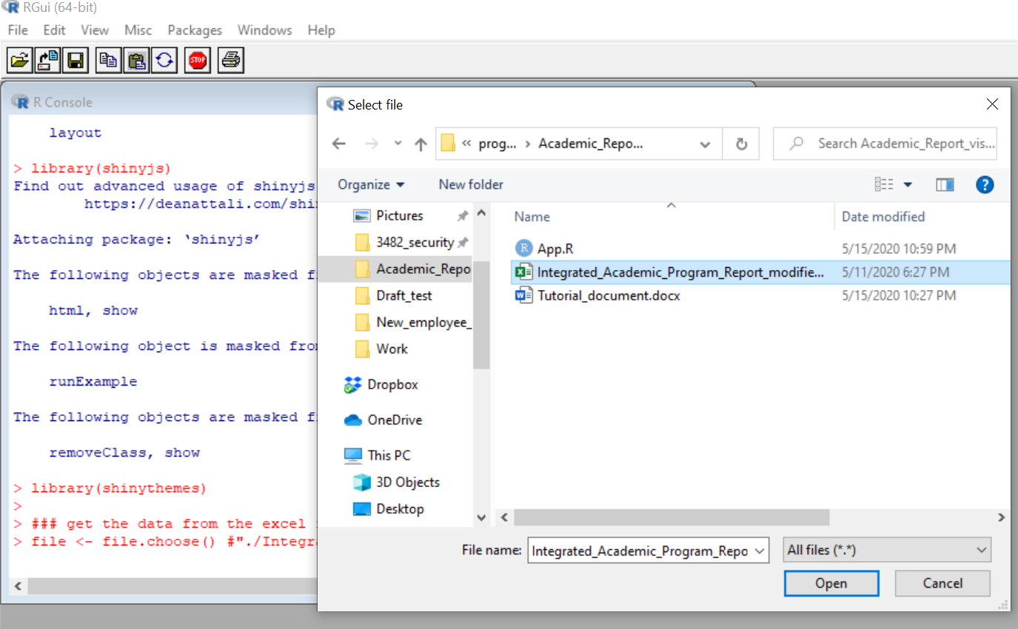

## Understanding the Excel Sheet

Below is a detailed example of a sheet.

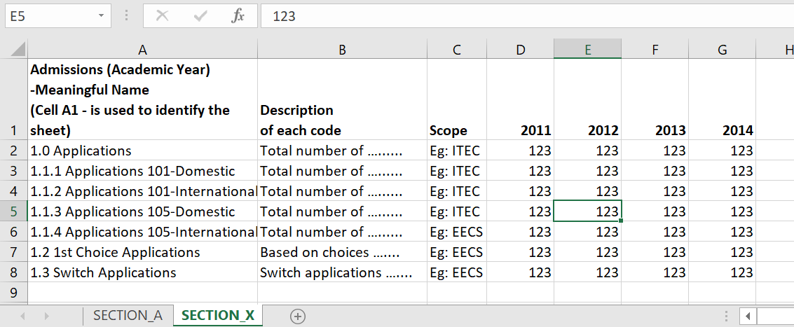

### *Updating Excel sheets*

All you need to do is add a new column as shown below (you do not have to highlight the column)

You can also add new rows of data (E.g. Data related to a new Code)

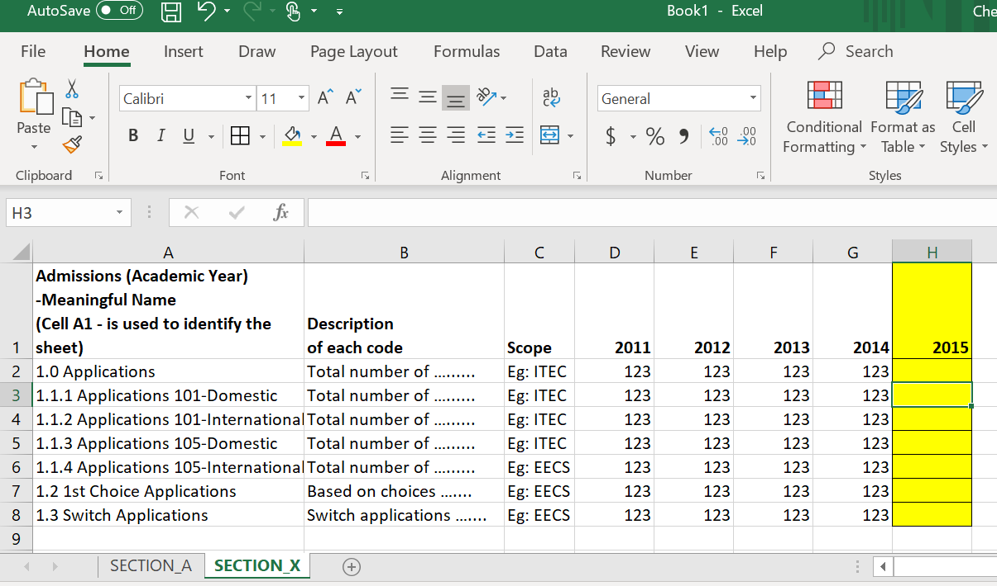

## Understanding the App

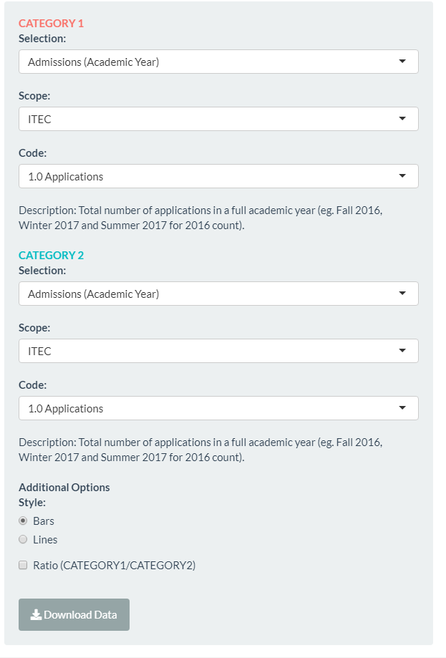

*Filters*

Mainly **2 CATEGORIES**,

**Selection:** Selecting a specific excel sheet from the Excel Workbook.

**Scope:** Selecting a specific Scope Eg: ITEC.

**Code:** Selecting the specific Code of data you are interested in

**Description:** For a better understanding of the Code selected.

**Radio Buttons (Style):** Option to select between Bar graph/Line graph.

**Check Box (Ratio):** Select to only view the ratio between the selected 2 data categories.

**Download Button:** To download the data used for the current comparison.